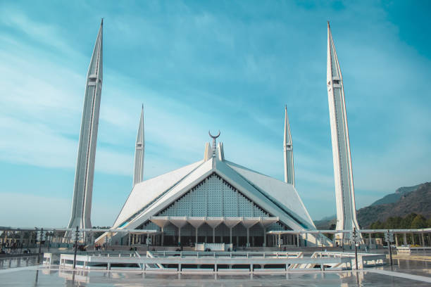

**Faisal Mosque**

A majestic marble marvel, the Faisal Mosque in Islamabad blends modern and traditional Islamic architecture.

**History**

Built as a symbol of friendship, the Faisal Mosque in Islamabad boasts a modern design inspired by Bedouin tents.